September 2022
Dear

Year 5/6 – Leadership Academy
Your son /daughter has been selected by the Head of PE at their school to be part of a selected group of young leaders to join the Worthing Schools Sports Association (WSSA) year 5/6 Leadership Academy.

Aims of the programme
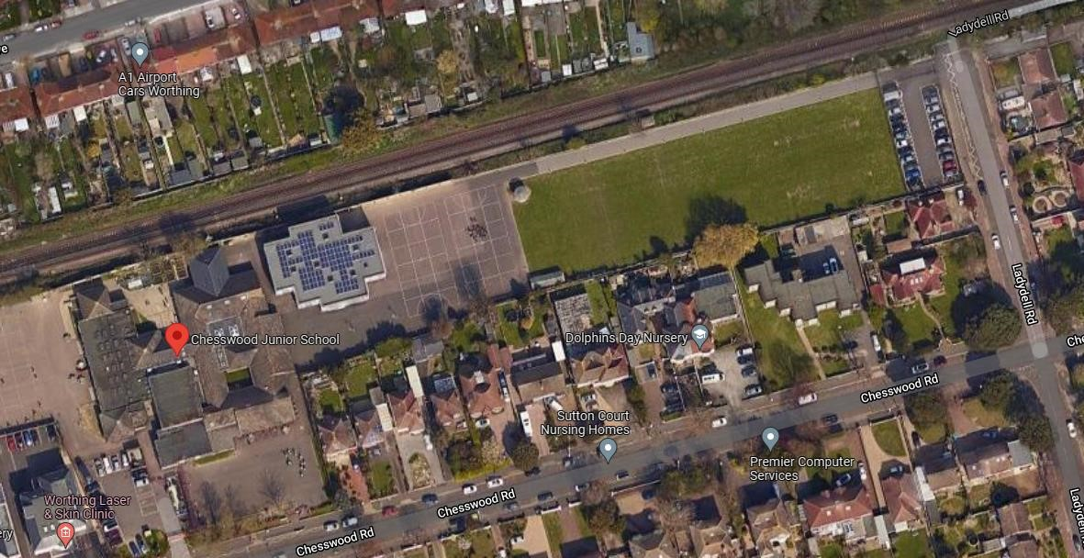
To offer students additional Leadership opportunities and training so they have the confidence to lead competitions and festivals in their own school.

To share strategies and ideas to help encourage those who are less active to participate in sport and physical activity.

Programme overview
Pupils will be invited to attend 4 sessions throughout the year. The first two will be on:
Tuesday 13th September – Team Building and Raising Participation
Tuesday 4th October – Competition Planning and Delivery.
Tuesday 18th April – Preparation for WSSA Tri Golf event.
Tuesday 25th April – Legacy Leaders will be running the WSSA Tri Golf event.
Sessions will be from 3. 45pm - 5.15pm and based at Chesswood Junior School, Chesswood Road, Worthing BN11 2AA. Please can all pupils enter the school site via the Ladydell Road entrance via the field, this will also be the collection point. Please do not arrive before 3.30pm as Chesswood pupils will still be leaving.
If you would like your son/daughter to be involved with this fantastic programme please confirm with the Head of PE at your school that you would like to take up the opportunity, complete the parental consent form via this link . https://forms.gle/MUGPszFeuLU61cgz7
This MUST be completed before the first session.
Should you have any further questions please do not hesitate to contact me on agroveswssa@gmail.com
Yours sincerely,

Alison Groves
(Worthing Schools PE and Sport Co ordinator)

