

2018 **Worthing Schools**

**Year 3-6 Legacy Games**

**Application form**

Name of school:

Mode of transport to Games:

Approximate arrival time:

|  |  |
| --- | --- |
| **Event** | **Number of teams** |
| Year 3 Challenges (4 in a team -2 boys 2 girls) |  |
| Year 4 Handball (5 in a team -7 in a squad) |  |
| Year 5 Rounders (8 in a team -4 boys /4 girls up to 10 in a squad) |  |
| Year 6 Cricket (6 a side up to 8 in a squad) |  |
| Athletics Yrs 3-6 |  |
| Boccia yrs 3-6 (3/4 in a team) SEND pupils |  |

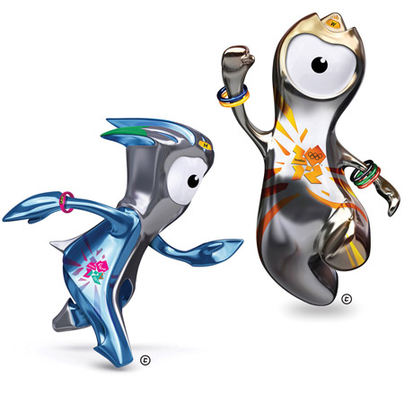How will your children be collected?

Signed ……………………… Date …………………………