GO Event Tour Sheet
Event – Worthing
Event | GO Event – The Gallops, Worthing
Date | Thursday 22nd October
Contacts | GRFF Contact:  Stephanie Pattinson (Tour Activator) 07712300537  Sarah Bull (Tour Activator) 07712300536  Brittany Pouresmaelieh (Tour Activator) 07429160316  Location Partners:  Julia Griggs, (The Vale First & Middle School Running Club) 07778509879  Sue Smith, School (Deputy Head)  Alison Groves, (School Sports Coordinator)  Additional Support:  Volunteers from the school (10-15 volunteers)  Members of The Vale First & Middle School Running Club
Location of event | The Gallops,  Bost Hill and Vale Drive  Worthing  West Sussex  BN13 3DA
Special Guest | Name  Image  Year – Competition, positioning in race
Participants | From local primary schools (As of 02.10.15)  SCHOOL NUMBERS  Durrington Infants & Junior 100  Orchards 100  Field Place 100  Springfield 12  Thomas A Becket 100  Vale 631  TOTAL 1043
Expected Numbers | 1050
Registration Process | Through school and The Vale Running Club
Event Details including timetable | Distance – 2km  Team on Site – 07:00  Set up – 07:10  Volunteers on site – 08:00  Volunteer briefing – 08:05  SESSION ONE: YEARS 1 TO 3  Children on site – 09:30  Introduction – 09:40  Warm up – 09:50  Children to start line – 10:00  Start of race – 10:10  Last runner in – 10:40  Cool down – 10:40  Q&A with Guest if present – 10:45  Children off site – 11:00  SESSION TWO: YEARS 4 TO 6  Children on site – 11:00  Introduction – 11:10  Warm up – 11:20  Children to start line – 11:30  Start of race – 11:40  Last runner in – 12:10  Cool down – 12:10  Q&A with Guest if present – 12:20  Children off site – 12:30  De-rig - 12:45  Team off site – 14:00
Route Map  The route is subject to change if required by weather and field conditions | 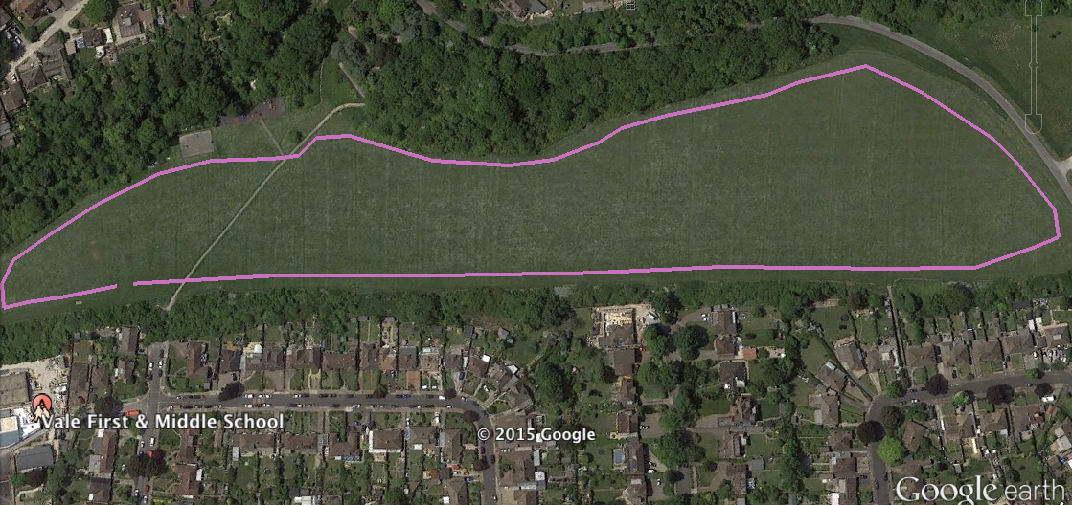
Race Numbers Requirement | Generic GRFF Race Number or Personalised to Event
T-Shirt Requirement | 400 Medium New Balance T-shirts  700 Large New Balance T-shirts  To be sent with Race Numbers
Branding Requirements | Tour Team Provide:  - GRFF Van  - Dart Mascot  - New Balance Trainer Mascot  - 8 x GRFF Flying Banners  - 4 x New Balance Flying Banners  - 12 x A-F Zone GRFF Flying Banners  - 1 x Start GRFF Flying Banner  - 1 x Finish GRFF Flying Banner  - GRFF New Balance Scrim  - GRFF – Event Signage e.g. Registration & Arrows  - GRFF Finish tape  - GRFF Course tape  - GRFF Inflatable Gantry  - GRFF New Balance Marquee  - 2 x GRFF New Balance Pop Up A Frames  Local partner(s) provide:  - Additional branding
PR Requirements | CONFIRM LOCATION PARTNER IS CONTACTABLE BY PR AGENCY  Gardiner Richardson to contact local XXXX Media.  GRFF team to update social media (Twitter, Facebook and Instagram)  GRFF team to update website and gallery.
Photography Consent Forms | Choose one of the below  All schools gain parental consent and then through our monitoring we establish those school children who cannot be photographed (using a ‘non-photograph’ sticker on their t-shirt).  Photography Consent is agreed upon when participants are registered online.
Missing Person Policy | This policy is covered in GRFF Tour Manual and is actioned by GRFF Tour Team and School
First Aid | All GRFF Tour Activators are First Aid qualified.  Anyone treated will be referred to a GP or a qualified medic.  All accidents will be recorded in the accident book.  In the event of more serious issues the 999 or 112 services will be used.  Confirm if British Red Cross are booked to attend.
Additional Requests | N/A
Post event feedback | TBC

INEOS GO Run for fun ACTIVATION TOUR EVENTSHEET RISK ASSESSMENT. Dynamic risk assessment to be updated up to date of the event. To be completed and signed on the day of the event.
IDENTIFIED HAZARD | PEOPLE AFFECTED | EXISTING CONTROLS | RISK LEVEL | FURTHER MEASURES
Course Route | Runners | - All course marshalled and clearly signposted  - Extra signage in place to warn public of event | Low | - Additional marshals in position where runners may come into contact with public
Vehicles / Buses on site | Teachers, event staff and runners | - Buses to drop children in adjacent car park  - Marshals to walk children to start line  - Family members to park in car park | Low | - Schools are encouraged to walk to site to reduce buses  - Marshals in place to monitor buses
Site plan of event | Teachers and runners | - Site plan designed  - Start and finish area designed and located in position to control children | Low | - Controlled registration zones to marshal children to start line  - Volunteers and marshals to assist
Park and Location | General Public, Teachers and runners | - Schools and Teachers send event plan and detail prior to event | Low | - The Gallops and The Vale Middle School aware of event
Facilities including toilets | Teachers and runners | - The Vale Middle School facilities | Low | - Schools will be responsible for children going into The Gallops
Crowd Control | Runners and spectators | - Designated area in place for spectators | Low | - Area cordoned off by stake and tape  - One volunteer assigned to manage zone
Completed by GRFF Team | Charlotte Allan & Steph Pattinson |  | DATE | 02.10.15
Event Day Completed by GRFF Team |  |  | DATE

