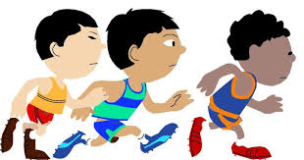
Year 1 /2 Multi skills Activities

- Standing Long Jump.
Challenge .Take off from 2 feet and land on 2 feet. Jumping over the furthest chalk line as you can.
4 mats required – 3 chalk lines on each mat. 1,2 and 3 points

XXXXX

- Target Throw ( x 4)
Yellow (3M away) Green (4M away) Blue (5M away)

Can you throw each of the bean bags into their correctly coloured hoop?

- Obstacle Relay (across the sports hall)
Children sit on a mat in the centre. Jump over 2 hurdles (SAQ), touch the turning board, run all the way to the other end, in and out of the rounders posts , next persons turn.
XXXXX

- Speed Bounce (4 mats)

How many speed bounces can you do in 10 seconds? (if the central triangle is too high replace with bean bags)

- Dribble the ball using a Hockey stick and a ball from the start line in and out of the cones and back to the finish?
start

Finish

- Football penalties (in the gym) 2 goals

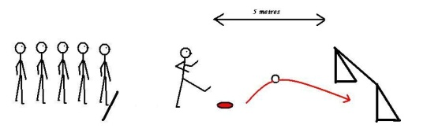

7.Shuttle runs (in the gym)
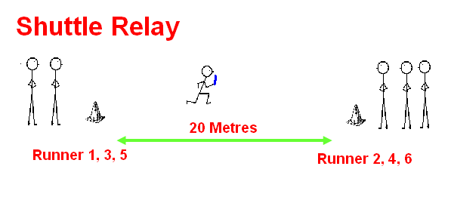
Teams run across the gym passing a relay baton

Equipment required
6 gym mats
Chalk
12 hoops
6 rounders posts
2 turning boards
2 large cones
4 SAQ hurdles
4 speed bounce mats
4 small hockey sticks
4 airflow balls
2 play balls
2 football goals
2 relay batons

