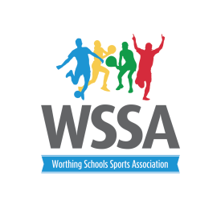
Boccia Tournament Legacy Games
Wednesday 20th June 2018 1.30pm – 3pm
Timings | Red Pool (pitch 1)  - Whytemead  - West Park A  - Vale B  - Durrington B  - Chesswood A | Black Pool (Pitch 2)  - Hawthorns  - West Park B  - Orchards B  - Broadwater A  - Laurels | Green Pool(Pitch3)  - Goring  - Vale A  - Orchards C  - Durrington A  5 Chesswood B | Blue Pool (Pitch4)  - West Park C  - Palatine  - Orchards A  - Downsbrook  - Broadwater B
 | 1v4 | 1v4 | 1v4 | 1v4
 | 2v3 | 2v3 | 2v3 | 2v3
 | 4v5 | 4v5 | 4v5 | 4v5
 | 3v1 | 3v1 | 3v1 | 3v1
 | 5v3 | 5v3 | 5v3 | 5v3
 | 1v2 | 1v2 | 1v2 | 1v2
 | 2v5 | 2v5 | 2v5 | 2v5
 | 3v4 | 3v4 | 3v4 | 3v4
 | 4v2 | 4v2 | 4v2 | 4v2
 | 5v1 | 5v1 | 5v1 | 5v1
Cup Games | Winner red V RU black | Winner Black V RU red | Winner Green V Runner Up blue | Winner Blue V Runner Up Green
Shield Games | 3rd Red V 4th Black | 4th Red V 3rd Black | 3rd Blue V 4th Green | 4th Blue V 3rd Green
Cup Games | Semi finals Cup -winner red pitch V winner black pitch | Semi finals Cup Winner Green Pitch V Winner blue pitch | Semi Finals Shield – Winner red pitch v Winner Black pitch | Semi Finals Shield Winner Green Pitch V Winner Blue pitch
Finals | Cup Finals | Shield Finals

