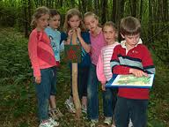
Team Challenges

4 pupils in a team (boys/girls)
Pupils solve different Physical and mental challenges e.g. How for their team to cross a “swamp “ using carpet tiles as stepping stones.
Located on the grass by the athletics throwing cage.
Pupils will be timed for the challenge and score points accordingly.

