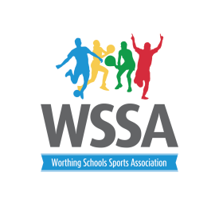

Worthing Schools Sports Association
Thursday 6th September
4pm Orchards Junior School

Agenda

- Introductions and welcome

- Apologies

- Minutes of last meeting and matters arising

- Talented and Gifted Gymnastics – Lauren Chaitow Durrington High School

- Quality Start Awards 2018

- Year 5 and 6 Football and Netball Leagues.

- Year 5 and 6 Football Knockout Cup

- WSSA membership 2018/19

- Sharing WSSA contacts

- CPD opportunities; Real PE, PE Refresh and Ultimate Frisbee

- Calendar 2018/19 clarification of events and opportunities until December 2018

- A.O.B.

