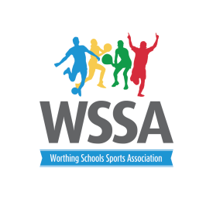

Worthing Schools Sports Association
Thursday 25th April 2019
3.45pm Orchards Junior School

Agenda

- Welcome back

- Apologies for absence

- Minutes of last meeting and matters arising

- Review of Spring term activities:
Football leagues – Yr 3 and 4,
Football Tournaments – Year 1/2, Years 3,4,5,6.
Netball tournaments: Years 4, 5 and 6
.Indoor athletics: Year 1 and 2 - Year 3 and 4.
New Age kurling
Year 4 Gymnastic, Year 6 Basketball, Swimming gala.
Year 5/6 Knockout Cup and Shield
Time to Dance.
- Balance of activities and format of competitions

- Quality Start and School Games Awards 2019

- Year 2 Legacy Games

- Year 3-6 Legacy Games. Confirmation of events

Athletics and Boccia –all years
Team Challenges – Year 3
Handball – Year 4
Stoolball/Rounders? Year 5
Street Cricket Year 6?

- Calendar of events until July 2019

- WSSA Membership 2019/2020

- Swimming data

- A.O.B.

