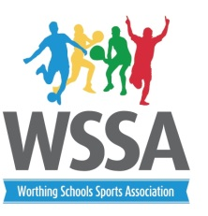

Dear

Year 3 Mini Leaders
Your son /daughter has been selected by the Head of PE at their school to be part of a selected group of young leaders to join the Worthing Schools Sports Association (WSSA) year 3 Mini Leaders.
Through the generous sponsorship of Jacobs Steel estate agent each student selected will receive a “Legacy Team” T shirt and be part of the wider WSSA Legacy Team.
Aims of the programme
To offer pupils additional Leadership opportunities and training so they have the confidence to lead playground challenges and competitions in their own school.
To share ideas to help encourage those who are less active to participate in sport and physical activity.
To support the development of a “Sports Crew” in their own school.
Programme overview
Pupils will be invited to attend 3 sessions during the year on Tuesday 20th January, Thursday 16th April and Monday 18th May 2015.
All sessions will be from 4.15pm -5.30pm and based at West Park First and Middle School.
If you would like your son/daughter to be involved with this programme please confirm with the Head of PE at your school that you would like to take up the opportunity, complete the attached parental consent form and bring it along with you to the first session.
Should you have any further questions please do not hesitate to contact me on agroves@theangmeringschool.co.uk

Yours sincerely

Alison Groves
(Worthing Schools PE and Sport Co ordinator)

