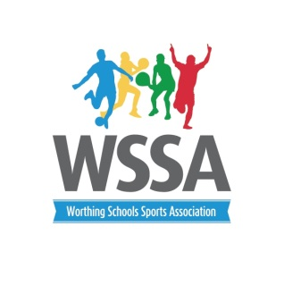
Year 5/6 Indoor Athletics

Small Schools
Programme Order
Track events will be year 5/6 girls followed by year 5/6 boys
3.45pm Obstacle Relay
4.00pm Speed Bounce
4.10 pm Girls Throwing Boys Jumping
4.20pm Boys Throwing Girls Jumping
4.25pm Parlauf
4.35pm 1+1 Relay
4.40pm 2+2 Relay
4.50pm 4x1 Relay
5pm Presentation

