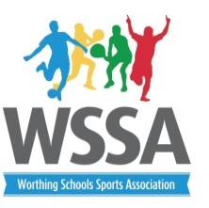

Year 6 Street Cricket
Legacy Games 2017

Pool A
- Chesswood
- Orchards
- English Martyrs
- Vale
- Durrington
- Downsbrook

Pool A Pitch 1 | Pool A Pitch 2
1v2 | 3v6
4v5 | 6v1
2v5 | 3v4
1v5 | 6v4
2v3 | 4v1
5v3 | 6v2
5v6 | 1v3
4v2
Results and presentation

